Artificial Intelligence Based Residential Security System



By

Abdullah Waseem

Iqra Bibi

Department of Information Technology

University of Haripur

June 2023

Artificial Intelligence Based Residential Security System



By

Abdullah Waseem F19-1210

Iqra Bibi F20-1966

Supervised byDr. Yousaf Saeed

Department of Information Technology

University of Haripur June 2023

Artificial Intelligence Based Residential Security System

By

Abdullah Waseem

Iqra Bibi

A Dissertation Submitted in Partial Fulfilment for the Degree of

BACHELOR OF SCIENCE

IN

COMPUTER SCIENCE

Department of Information Technology

University of Haripur

June 2023

By

Abdullah Waseem, Iqra Bibi

Artificial Intelligence Based Residential Security System

CERTIFICATE

A THESIS SUBMITTED IN THE PARTIAL FULFILMENT OF THE

REQUIRMENTS FOR THE DEGREE OF BACHELORS

IN COMPUTER SCIENCE

We accept this dissertation as conforming to the required standards.

Dr. Yousaf

__________________________ _____________________________

Supervisor Name Dr. Yousaf Saeed

Project Supervisor Final Year Project

Coordinator

___________________________ ____________________________

Examiner Name Mr. Muhammad Junaid

External Examiner Head of Department

Department of Information Technology

University of Haripur

June 2023

Declaration

I hereby declare that this dissertation is neither as a whole or part thereof has been copied out from any source. If any part of this thesis is proved to be copied or found to be a report of some other, we shall bear the consequences. No portion of this work presented in the thesis has been submitted in support of any application from any other degree of qualification or any other university or any other institute of learning.

I further declare that this research and all the associated documents with this, reports and all records are submitted as a partial requirement of the degree of bachelor’s in computer science. We understand and transfer copyrights for these materials to University of Haripur and we will not sale this research and documents for getting any financial gains. It is further declared that I developed this and this thesis is entirely on the basis of our personal efforts made under the sincere guidance of the project supervisor Dr. Yousaf Saeed, Department of Information Technology, University of Haripur, Haripur.

Date: June 2023 *Abdullah Waseem Iqra Bibi*

*Signatures*

Plagiarism Certificate

This thesis has been checked for Plagiarism. The Turnitin report endorsed by the Supervisor is attached at the end of thesis.

Date: June 2023 Abdullah Waseem, Iqra Bibi

Student Name(s)

Student Signature

Supervisor Signature

Dedicated to

***We would like to extend our heartfelt gratitude to our loving parents and dedicated teachers, especially Dr. Yousaf, who has been a source of inspiration and support throughout our journey on this project.***

***With his guidance and encouragement, we have been able to overcome challenges and strive for excellence. We are truly grateful for his unwavering commitment to our growth and development.***

Acknowledgements

***I would like to express my deepest gratitude and appreciation to my supervisor for their guidance, encouragement, and support throughout the course of this thesis. Their valuable feedback and constructive criticism helped me in shaping and improving this work.***

***I would also like to extend my heartfelt thanks to my family and friends for their unwavering support and encouragement during this challenging journey. Their love and belief in me kept me motivated and focused.***

***Finally, I would like to acknowledge the participants who volunteered their time and provided their valuable insights, which were crucial in making this study a success.***

***Thank you all for your invaluable contributions.***

Abstract

The rise of smart homes and the Internet of Things (IoT) has led to the development of various home security systems. However, most of these systems rely on traditional security methods and are not as efficient as they could be. In this project, we propose a home security system that utilizes AI-based face detection and recognition to improve security measures. The system uses a Raspberry Pi as the control unit and a USB camera to detect and recognize faces at the entrance of the home. Once a person comes in front of the IR sensor, the system activates the camera to capture the face for detection and recognition. If the detected face belongs to a registered family member, the system remains idle. However, if the face is unrecognized, the system sends a notification to the homeowner's registered email, indicating the presence of an outsider. The email notification includes an attached image of the recognized face for easy identification. This ensures that homeowners are alerted in real-time with visual evidence and can take necessary action to prevent any potential security breaches. The proposed system offers full control and monitoring of home security remotely via smartphone and cloud-based data storage. By incorporating motion sensor activation, the system conserves power and optimizes camera usage, focusing only on relevant moments when someone is detected near the entrance. With the inclusion of face detection and recognition technology, IR sensor integration, and image attachments in email notifications, this home security system represents a significant improvement over traditional security system.

Table of Contents

**Chapter 1** 13

**Introduction:** 13

**1.1** **Background:** 14

**1.2** **Smart Home** 14

1.2.1 Keypad or PIN-Based Systems: 15

1.2.2 Motion Sensor Systems: 15

1.2.3 Closed-Circuit Television (CCTV) Systems: 15

1.2.4 Door and Window Sensors: 16

1.2.5 Security Alarms: 16

**1.3** **Need of Security:** 16

1.3.1 Protection against intrusions: 16

1.3.2 Deterrence of criminal activity: 17

1.3.5 Safety for residents and belongings: 17

1.3.4 Prevention of property damage or loss: 17

1.3.5 Monitoring and surveillance capabilities: 17

**1.4** **Better Security with AI and IoT:** 17

**1.5** **Importance of Home Security and Automation:** 18

**1.6** **Raspberry Pi 3b+:** 19

1.6.1 Introduction to Raspberry Pi in Home Security Systems: 19

1.6.2 Raspberry Pi as a Central Hub: 19

1.6.3 Video Surveillance with Raspberry Pi: 19

1.6.4 Intrusion Detection and Alarm Systems: 20

1.6.5 Access Control and Smart Lock Integration: 20

1.6.6 Home Automation and Security Integration: 20

**Chapter 2** 21

**Existing Systems:** 21

**2.1** **Introduction to Existing Home Security systems:** 21

**2.2** **Traditional Home Security Systems:** 22

2.2.1 Limited Protection: 22

2.2.2 False alarms: 22

2.2.3 Costly maintenance: 22

2.2.4 Limited remote access: 23

**2.3** **Modern Home Security Systems:** 23

2.3.1 Wi-Fi-Enabled Security Cameras: 23

2.3.2 Smart Locks: 24

2.3.3 Video Doorbell Systems: 24

2.3.4 Home Automation Integration: 24

2.3.5 Limited Scalability and Customization: 24

**2.4** **Sensor-Based Security Systems:** 24

2.4.1 Motion Sensor Systems: 24

2.4.2 Door/Window Sensor Systems: 25

2.4.3 Glass Break Sensors: 25

2.4.4 Smoke/Carbon Monoxide Detectors: 25

2.4.5 Limitations of Sensor-Based Systems: 25

**2.5** **Mobile-App Enabled Security Systems:** 25

2.5.1 Remote Control and Monitoring: 26

2.5.2 Dependence on Internet Connectivity: 26

2.5.3 Vulnerability to Hacking and Cyber Threats: 26

2.5.4 Limited Integration and Compatibility: 26

2.5.5 Reliance on Smartphone Battery and Accessibility: 26

**2.6** **Surveillance Camera Systems:** 27

2.6.1 Visual Monitoring: 27

2.6.2 Limited Field of View and Blind Spots: 27

2.6.3 False Alarms and Nuisance Notifications: 27

2.6.4 Image Quality and Resolution: 27

2.6.5 Storage and Retrieval Challenges: 28

2.6.6 Lack of Advanced Security Features: 28

2.6.7 Installation and Maintenance: 28

**2.7** **Limitations of Existing Home Security Systems:** 28

2.7.1 Limited coverage: 28

2.7.2 False alarms: 28

2.7.3 High cost: 28

2.7.4 Lack of flexibility: 29

2.7.5 Dependence on power and internet: 29

2.7.6 Complexity: 29

**2.7** **Comparison of Existing Home Security Systems with Proposed System:** 29

**Chapter 3:** 30

**System Modeling:** 30

**3.1** **Improving Security With AI, IoT and Raspberry Pi:** 31

3.1.2 Integration of Face Detection and Recognition: 31

3.1.2 Comparison With Traditional Home Security Systems: 31

3.1.3 Scalability and Customization: 32

3.1.4 Use of Raspberry Pi and Open-Source Software: 32

**3.2** **Software and Hardware Used in Proposed System:** 33

3.2.1 Software: 33

3.2.2 Hardware: 34

**3.3** **Structural Model:** 35

3.3.1 System Components: 35

3.3.2 Relationships and Connections: 36

3.3.3 Class Diagram & Details: 37

**3.4** **Behavioral Model:** 38

3.4.1 System Operation: 38

3.4.2 Face Verification Process: 39

3.4.3 Continuous Monitoring: 39

3.4.4 Sequence Diagram & Details 39

3.4.5 Flowchart Diagram & Details: 40

**3.5** **Data Model:** 41

3.5.1 Entity Relationship Diagram: 41

**3.6** **System Development Environment & Tools:** 42

3.6.1 Development Environment: 42

3.6.2 Development Tools: 43

3.6.3 Project Documentation: 43

3.6.4 Project Diagrams 43

**Chapter 1**

## **Introduction:**

In recent years, the Internet of Things (IoT) has emerged as a powerful technology that offers exciting opportunities to increase the connectivity of gadgets inside the home for the cause of domestic automation. One of the key advantages of IoT is its ability to provide a wide range of capabilities to the end-users, making it an ideal platform for developing home automation systems. Among the various IoT devices, smartphones have gained significant popularity due to their portability and ease of use, making them perfect for providing a consumer interface in a home automation system.

The primary goal of this project is to design and implement an efficient domestic automation system with a focus on safety, utilizing the capabilities of AI, IoT and Raspberry Pi. Specifically, we propose a home security system that provides the user with remote control over various controllable factors in the home and automates the residence entrance. Our proposed system includes a webcam at the entrance of the home connected to a Raspberry Pi, which utilizes Face Detection and Face Recognition features to automate access to the door while simultaneously sending a message in the form of a photograph to the registered e-mail ID.

The software and hardware involved in the project is.

The proposed home security system utilizes a range of **hardware components** to ensure safety and security in the home. The primary control unit for the system is a Raspberry Pi, a popular single-board computer that offers excellent performance and flexibility. The Raspberry Pi is connected to several hardware devices, including a IR sensor and a USB camera. The motion sensor detects motion in the vicinity of the system, while the USB camera is utilized for AI-based Face Detection and Face Recognition features.

The **software** used in the proposed system is critical in ensuring the efficiency and effectiveness of the system. The system utilizes AI-based Face Detection and Face Recognition algorithms, which allow for automated access to the residence entrance while simultaneously sending a message in the form of a photograph to the registered e-mail ID.

Overall, the hardware and software used in the proposed home security system are carefully selected to ensure that the system is efficient, effective, and easy to use. By combining the capabilities of IoT, AI-based Face Detection and Face Recognition algorithms, and cloud-based data management, the proposed system offers a comprehensive solution to home security and automation that is both safe and convenient for the end-users.

* 1. **Background:**

Before the invention of security or surveillance systems, people used physical barriers such as locks, gates, and walls to protect their homes from intruders. They also employed guards to monitor the area and ensure safety. As technology advanced, traditional security systems such as alarms and cameras were introduced, but they were often expensive and required professional installation. With the advent of the Internet of Things (IoT) and artificial intelligence (AI), home security and automation systems have become more accessible, affordable, and efficient. These systems can provide a higher level of security with features such as remote access, automated alerts, and intelligent recognition technology.

* 1. **Smart Home**

Smart homes have revolutionized the way we interact with and control various aspects of our living spaces. These technologically advanced residences offer a wide range of interconnected devices and systems designed to enhance convenience, energy efficiency, and security. While many smart home technologies have made significant advancements.

Some smart home technologies, while providing certain conveniences, may fall short in terms of security or advanced features. These systems often rely on basic automation and remote-control capabilities. Let's explore a few examples:

* **Basic home automation systems:** Some smart home systems focus primarily on controlling lighting, HVAC, and appliances. While they offer convenience in terms of scheduling and remote control.
* **Voice-controlled assistants with limited capabilities:** Voice-activated devices like Amazon Echo with Alexa or Google Home can perform tasks such as controlling lights, playing music, or providing basic information.
* **Standalone security systems:** Certain smart home security systems primarily focus on traditional security measures, such as door/window sensors, motion detectors, and surveillance cameras. While they offer monitoring and remote access.
* **Partial integration of security features:** Some smart home systems may integrate basic security features like surveillance cameras or doorbell cameras.
  + 1. Keypad or PIN-Based Systems:

Keypad or PIN-based systems have long been a staple in residential security, offering a straightforward and accessible means of securing homes. These systems require residents to input a specific code or PIN to arm or disarm the security system. With their simplicity and ease of use, keypad or PIN-based systems have been widely adopted by homeowners.

* + 1. Motion Sensor Systems:

Motion sensor systems are an essential component of residential security, providing an effective means of detecting movement within a designated area. These systems employ sensors that can detect changes in infrared radiation or other physical movements, triggering an alarm or activating other security measures. Motion sensor systems are commonly used both indoors and outdoors to monitor areas such as entry points, hallways, or yards. They serve as a proactive security measure, alerting homeowners to potential intrusions and deterring unauthorized access.

* + 1. Closed-Circuit Television (CCTV) Systems:

Closed-circuit television (CCTV) systems have long been a prevalent security solution for residential properties. These systems consist of cameras that capture video footage of the surroundings, which can be monitored in real-time or recorded for later review. CCTV systems serve as a deterrent to potential intruders, as the presence of visible cameras can discourage unlawful activities. They offer homeowners the ability to monitor their property remotely, enhancing surveillance capabilities and providing a sense of security. While CCTV systems are effective in capturing video evidence and identifying potential threats

* + 1. Door and Window Sensors:

Door and window sensors are fundamental components of residential security systems, offering a reliable means of detecting unauthorized entry. These sensors are typically installed on doors and windows and consist of magnetic contacts that trigger an alarm when the door or window is opened. Door and window sensors act as a first line of defense, alerting homeowners to potential intrusions and providing an immediate response to protect the property.

* + 1. Security Alarms:

Security alarms are a cornerstone of residential security systems, providing robust and audible alert in the event of an unauthorized intrusion. These alarms consist of sensors, such as motion detectors, door/window sensors, or glass break sensors, which are strategically placed throughout the property. When triggered, security alarms emit a loud sound, acting as a powerful deterrent and alerting homeowners, neighbors, or security personnel to the potential threat.

* 1. **Need of Security:**

Security is a fundamental need for individuals, families, and communities. It serves to protect people, their belongings, and their way of life. The need for security arises from the inherent desire to feel safe and protected from potential harm or threats. Security measures provide a sense of peace, allowing individuals to go about their daily lives without constant fear or anxiety. They act as a deterrent to criminal activity, preventing intrusions, theft, and vandalism. Security also helps mitigate risks, whether it be physical dangers or cyber threats, ensuring the well-being and privacy of individuals. By implementing robust security systems and practices, we can create an environment that promotes safety, safeguards our assets, and fosters a sense of trust and stability within our communities.

* + 1. Protection against intrusions:

Security measures are essential for safeguarding homes from unauthorized entry. By implementing robust security systems, such as alarms, surveillance cameras, and access control mechanisms, homeowners can significantly reduce the risk of intrusions and protect their property.

* + 1. Deterrence of criminal activity:

Visible security measures act as a powerful deterrent, discouraging potential criminals from targeting a residence. Security signage, well-lit areas, and surveillance cameras can make intruders think twice before attempting any unlawful activity.

* + 1. Safety for residents and belongings:

A secure environment ensures the safety of residents and their belongings. By implementing security measures such as alarms, locks, and surveillance systems, homeowners can provide a sense of safety and protect their loved ones and valuable possessions from theft or harm.

* + 1. Prevention of property damage or loss:

Security measures can help prevent property damage or loss due to break-ins or vandalism. Intrusion detection systems and alarms can immediately alert residents or authorities, enabling swift action to mitigate potential damage and loss.

* + 1. Monitoring and surveillance capabilities:

Surveillance cameras and monitoring systems enable homeowners to keep an eye on their property, both in real-time and through recorded footage. Monitoring capabilities allow for early detection of suspicious activities and can provide valuable evidence in case of incidents.

* 1. **Better Security with AI and IoT:**

The use of AI and IoT technologies for home security offers several advantages over traditional security systems, including those that rely on security guards or do not use any technology.

**Firstly**, AI-based face recognition and detection technology can detect and recognize the faces of authorized persons and allow them access to the home, while denying access to unauthorized persons. This eliminates the need for physical keys or security guards, which can be lost or compromised, and ensures that only authorized persons can enter the home.

**Secondly**, IoT-based home automation systems offer real-time monitoring and control of the home environment, which means that homeowners can receive alerts and notifications on their smartphones if any unusual activity is detected. This enables them to take immediate action to prevent any potential security breaches, without relying on security guards who may not be able to respond quickly.

**Thirdly**, the system offers remote access. This improves the overall security of the home by allowing homeowners to monitor and control the system even when they are not physically present.

**Finally**, the use of AI and IoT technologies for home security is cost-effective in the long run. The cost of hiring security guards can be high, and they may not always be reliable or effective in preventing security breaches. IoT-based home automation systems with AI-based face recognition and detection technology offer a one-time investment that can provide long-term security and safety benefits.

So, the use of AI and IoT technologies for home security offers a higher level of security and safety as compared to traditional security systems that rely on security guards or do not use any technology.

* 1. **Importance of Home Security and Automation:**

Home security and automation are important for several reasons. Firstly, they help to keep homeowners and their families safe from potential security breaches, such as break-ins, theft, or vandalism. By installing a home security system with AI-based face recognition and detection technology and IoT-based home automation systems, homeowners can monitor their homes in real-time and receive alerts and notifications if any unusual activity is detected.

Home automation systems offer several benefits, such as increased convenience, energy efficiency, and cost savings. With an IoT-based home automation system, homeowners can control various devices and appliances in their home remotely, using their smartphones or other mobile devices. This can help to save energy and reduce utility bills.

Home security and automation systems can increase the value of the home. Homebuyers today are looking for homes that are equipped with modern amenities, including home automation and security systems. By installing such systems in their homes, homeowners can increase their home's value and attract potential buyers.

Home security and automation are important for ensuring the safety and security of the home and its occupants, as well as providing convenience, energy efficiency, and cost savings. By investing in a home security and automation system with AI-based face recognition and detection technology and IoT-based home automation systems, homeowners can enjoy peace of mind knowing that their home is safe and secure.

* 1. **Raspberry Pi 3b+:**

Raspberry Pi 3 B+ is a single-board computer that offers a compact and affordable solution for various computing projects. It features a 1.4GHz quad-core ARM Cortex-A53 processor, 1GB of RAM, and onboard Wi-Fi and Bluetooth connectivity. The board also includes a set of GPIO (General Purpose Input/Output) pins, which allow for easy integration with sensors, actuators, and other electronic components. Raspberry Pi 3 B+ supports a range of operating systems, including Linux-based distributions, making it a versatile platform for programming and development. With its small form factor and low power consumption, the Raspberry Pi 3 B+ is well-suited for applications such as home automation, robotics, media centers, and yes, even home security systems. Its accessibility and strong community support have made it a popular choice for enthusiasts and professionals alike.

* + 1. Introduction to Raspberry Pi in Home Security Systems:

Raspberry Pi, a versatile single-board computer, has gained popularity for its applications in various domains, including home security systems. Its compact size, affordability, and GPIO (General Purpose Input/Output) pins make it an ideal platform for creating customized security solutions.

* + 1. Raspberry Pi as a Central Hub:

Raspberry Pi can serve as a central hub for connecting and controlling different components of a home security system. It can integrate sensors, cameras, alarms, and other devices, allowing for centralized management and monitoring.

* + 1. Video Surveillance with Raspberry Pi:

By connecting cameras to Raspberry Pi, homeowners can set up a cost-effective video surveillance system. Raspberry Pi can process and store video footage, enabling real-time monitoring or reviewing recorded footage remotely.

* + 1. Intrusion Detection and Alarm Systems:

Raspberry Pi can be used to create intrusion detection systems that utilize various sensors, such as motion detectors or door/window sensors. When triggered, it can activate alarms or send notifications to alert homeowners of potential security breaches.

* + 1. Access Control and Smart Lock Integration:

With Raspberry Pi, access control systems can be implemented, allowing homeowners to remotely control and monitor entry points. Integration with smart locks enables secure and convenient access management, providing keyless entry options and tracking access events.

* + 1. Home Automation and Security Integration:

Raspberry Pi can be integrated with home automation systems, allowing for seamless integration of security features. It enables automation of lighting, HVAC, and other devices based on security triggers, enhancing energy efficiency, and creating a more secure environment.

**Chapter 2**

## **Existing Systems:**

* 1. **Introduction to Existing Home Security systems:**

Home security systems have been in use for several decades, with the aim of ensuring the safety of homes and their inhabitants. These systems have evolved over the years, from simple alarm systems to more sophisticated ones that use advanced technology. In this chapter, we will explore some of the existing home security systems, their features, and their limitations. We will also discuss the need for a more advanced and comprehensive home security system that can address the shortcomings of existing ones.

Some home security systems are designed to protect homes from unauthorized access, theft, and burglary. They usually consist of a central control panel, sensors, and alarms. The sensors are placed on windows, doors, and other potential entry points and are triggered if there is any attempt to open or break them. The control panel receives signals from the sensors and activates the alarms to alert the homeowners or a security monitoring service. Some systems may also include surveillance cameras and remote access capabilities, allowing homeowners to monitor their homes from their mobile devices or computers. However, traditional home security systems have limitations and may not be able to prevent all types of break-ins or provide adequate protection against more sophisticated threats.

* 1. **Traditional Home Security Systems:**

Traditional home security systems typically consist of basic alarm systems that include door and window sensors, motion detectors, and sometimes security cameras. These systems rely on the homeowner to activate and deactivate the system manually and alert the authorities if necessary. Some traditional systems may also include a monitoring service that notifies the authorities in the event of an alarm.

One disadvantage of traditional home security systems is that they are often limited in their capabilities and can only detect a limited range of events, such as door or window intrusion. They are also typically reactive, meaning they only alert the homeowner or authorities after an intrusion has already occurred. This can lead to delayed response times and potentially result in property damage or loss.

Moreover, traditional home security systems are not easily customizable, and their installation and maintenance can be costly. They are also susceptible to false alarms, which can lead to the homeowner being charged for unnecessary emergency services. In summary, traditional home security systems have limitations and may not be adequate for providing comprehensive protection for a home.

Traditional home security systems refer to non-automated systems that rely on physical locks, alarms, and human presence, such as security guards. These systems have several disadvantages, including:

#### Limited Protection:

Traditional systems offer limited protection as they can only detect and alert against certain types of threats. They cannot provide comprehensive monitoring of the home.

#### False alarms:

Traditional systems are often prone to false alarms, which can be triggered by pets, small movements, or other non-threatening factors. False alarms can lead to unnecessary stress and anxiety for the homeowner.

#### Costly maintenance:

Traditional systems require regular maintenance, including battery replacements, software updates, and physical inspections. This can be costly and time-consuming.

#### Limited remote access:

Traditional systems offer limited remote access, which means that homeowners cannot monitor their homes when they are away. This can leave the home vulnerable to theft and other threats.

* 1. **Modern Home Security Systems:**

In recent years, there has been a growing interest in modern home security systems as homeowners seek to protect their properties and loved ones from potential threats. These systems have witnessed significant advancements in technology, providing homeowners with a range of options to enhance their security measures. While these systems have undoubtedly brought improvements compared to traditional security methods, they still face certain limitations that hinder their overall effectiveness.

Traditional home security systems primarily rely on alarm-based systems, sensor-based systems, surveillance cameras, keypad entry systems, or a combination of these approaches. While these systems have been the go-to solution for many years, they often fall short in addressing the evolving nature of security threats. Alarm-based systems, for instance, can be prone to false alarms or may not effectively deter determined intruders. Sensor-based systems are limited to detecting specific types of movement and may not capture subtle or sophisticated intrusion attempts. Surveillance camera systems suffer from blind spots and may fail to provide actionable information in critical moments. Keypad entry systems, although providing a means to restrict access, can be vulnerable to unauthorized access if the codes are compromised.

Considering these limitations and challenges, it becomes evident that there is a need for a modern home security system that leverages advanced technologies to overcome the shortcomings of existing solutions. This is where the proposed system aims to make a significant difference.

#### Wi-Fi-Enabled Security Cameras:

Wi-Fi-enabled security cameras have become popular for home surveillance. They offer features like live video streaming, motion detection, and remote access through mobile apps. However, these cameras often have limitations such as limited field of view, lower image quality, and the need for a stable internet connection for optimal performance.

#### Smart Locks:

Smart locks allow homeowners to remotely lock and unlock doors using a smartphone or a key fob. While these locks enhance convenience and eliminate the need for physical keys, they may have vulnerabilities associated with their wireless communication.

#### Video Doorbell Systems:

Video doorbell systems have gained popularity, allowing homeowners to see and communicate with visitors remotely through their smartphones. While these systems provide visual identification, they often rely on the homeowner actively monitoring the video feed. This system, with its AI-based face detection and recognition, offers more proactive security measures by automatically identifying unfamiliar faces and sending real-time notifications.

#### Home Automation Integration:

Many modern home security systems integrate with home automation devices to create a smart home ecosystem. While this integration offers convenience and control, it may not necessarily enhance security beyond the basic features provided by this proposed system. The focus on face detection and recognition in this project adds a unique and advanced layer of security that is not commonly found in standard home automation setups.

#### Limited Scalability and Customization:

Some modern home security systems have limitations when it comes to scalability and customization. Adding additional sensors or expanding the system to cover larger areas may be challenging or require professional assistance.

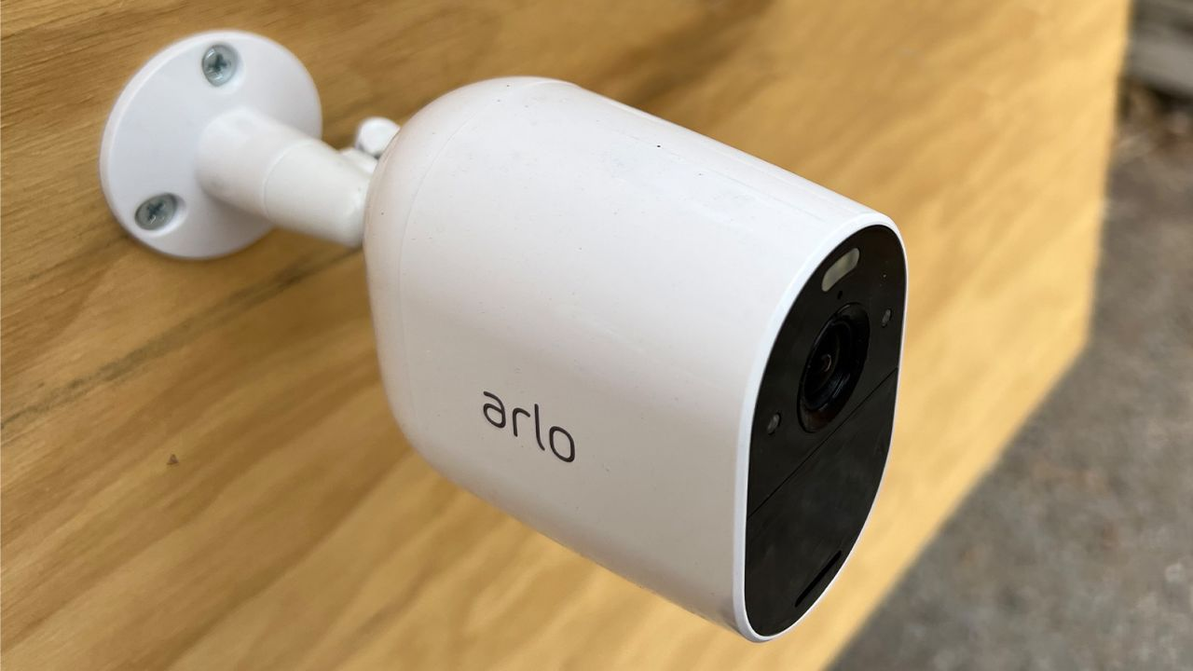

* 1. **Sensor-Based Security Systems:**

Sensor-based security systems have been widely used in homes to detect and respond to potential security threats. While these systems have provided a certain level of protection, they possess limitations that make them less effective compared to the proposed project. Here, we will explore the features and drawbacks of sensor-based security systems.

#### Motion Sensor Systems:

Motion sensor-based security systems are commonly used to detect movement within a specific area of a home. These systems rely on infrared, microwave, or ultrasonic sensors to detect changes in the environment. However, they can be prone to false alarms triggered by pets, moving objects, or environmental factors like changes in temperature or lighting conditions. This can lead to unnecessary alerts and potential complacency in responding to genuine threats.

#### Door/Window Sensor Systems:

Door and window sensors are designed to detect unauthorized entry by triggering an alarm when a door or window is opened or tampered with. While these systems are effective at detecting forced entry, they may not be as reliable when it comes to subtle or sophisticated intrusion attempts. Intruders who are skilled at bypassing or disabling these sensors may still gain access without triggering the alarm.

#### Glass Break Sensors:

Glass break sensors are designed to detect the sound or vibration of glass breaking, alerting homeowners to potential break-ins through windows or glass doors. However, they have limitations in terms of range and sensitivity. For instance, they may not be as effective in detecting breaking glass in large or open spaces, and false alarms can be triggered by loud noises unrelated to security threats.

#### Smoke/Carbon Monoxide Detectors:

While not solely focused on security, smoke and carbon monoxide detectors are essential components of home safety. However, they primarily serve as life-safety devices rather than comprehensive security solutions. These detectors alert occupants to potential fires or carbon monoxide leaks but do not address issues such as burglary or unauthorized access.

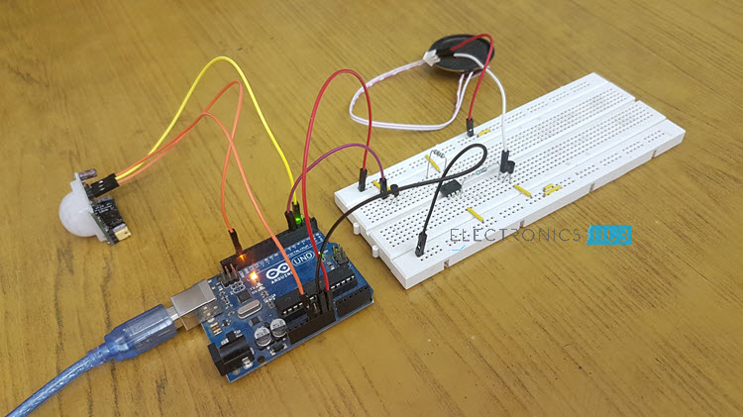

* 1. **Mobile-App Enabled Security Systems:**

Mobile app-enabled security systems have gained popularity in recent years, offering homeowners the convenience of controlling and monitoring their home security through their smartphones. While these systems have their advantages, they fall short compared to your proposed system in several key areas. Let's explore the features and limitations of mobile app-enabled security systems.

#### Remote Control and Monitoring:

Mobile app-enabled security systems allow homeowners to remotely arm and disarm their security systems, receive real-time notifications, and access live video feeds from surveillance cameras. However, these systems are typically limited to basic functionalities such as controlling alarms and accessing live feeds. They may lack more advanced features, such as AI-based face detection and recognition.

#### Dependence on Internet Connectivity:

Mobile app-enabled security systems rely heavily on internet connectivity to function effectively. A stable and reliable internet connection is necessary for remote access and control. However, intermittent, or disrupted internet connectivity can render these systems temporarily inaccessible or ineffective, potentially leaving homeowners unaware of security events or unable to take immediate action.

#### Vulnerability to Hacking and Cyber Threats:

The integration of mobile apps and internet connectivity introduces potential vulnerabilities to hacking and cyber threats. If the security of the mobile app or associated cloud services is compromised, unauthorized access to the security system or sensitive data may occur. Ensuring robust security measures, such as encryption and regular updates, becomes crucial to mitigate these risks.

#### Limited Integration and Compatibility:

While mobile app-enabled security systems offer convenience, they may have limitations when it comes to integrating with other smart home devices or systems. Compatibility issues can arise, preventing seamless integration and interoperability. This may restrict the ability to create a comprehensive and unified home security ecosystem.

#### Reliance on Smartphone Battery and Accessibility:

Mobile app-enabled security systems require the homeowner to have their smartphone accessible and always charged. In situations where the smartphone is lost, stolen, or out of battery, accessing and controlling the security system becomes challenging or impossible. This dependence on a single device for security management introduces a potential point of failure.

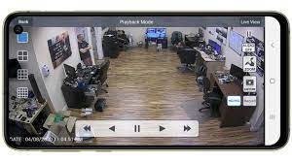

* 1. **Surveillance Camera Systems:**

Surveillance camera systems have long been a popular choice for home security, providing visual monitoring and evidence documentation. While these systems offer certain benefits, they have limitations that make them less effective compared to your proposed project. Let's explore the features and drawbacks of surveillance camera systems.

#### Visual Monitoring:

Surveillance camera systems enable homeowners to monitor their property visually through live video feeds or recorded footage. However, these systems typically require constant monitoring to be effective, as they rely on the homeowner actively observing the camera feeds. This can be time-consuming and may not be feasible for individuals with busy schedules or when homeowners are away from their property.

#### Limited Field of View and Blind Spots:

Surveillance cameras have a specific field of view, limiting their coverage to a specific area or angle. This can result in blind spots or areas that are not effectively monitored. Intruders can exploit these blind spots to gain unauthorized access or engage in criminal activities undetected.

#### False Alarms and Nuisance Notifications:

Surveillance camera systems that rely on motion detection algorithms may generate false alarms or nuisance notifications triggered by non-threatening events such as animals, moving trees, or changes in lighting conditions. This can lead to an increased number of irrelevant notifications, potentially desensitizing homeowners and reducing their responsiveness to genuine security threats.

#### Image Quality and Resolution:

The image quality and resolution of surveillance cameras can vary significantly depending on the camera's specifications and cost. Lower-priced cameras may have lower resolution, resulting in less clear and detailed images. This can impact the ability to identify individuals or capture critical details during security incidents.

#### Storage and Retrieval Challenges:

Surveillance camera systems often require ample storage space to store recorded video footage. Retrieving specific footage from a vast amount of recorded data can be time-consuming and cumbersome, particularly if the system does not have advanced search and playback functionalities. This can hinder the homeowner's ability to quickly access and review relevant footage in the event of a security incident.

#### Lack of Advanced Security Features:

Traditional surveillance camera systems generally focus on video recording and monitoring, lacking advanced security features found in more innovative solutions.

#### Installation and Maintenance:

Setting up surveillance camera systems can require professional installation, particularly for complex setups involving multiple cameras and wiring. Maintenance and periodic adjustments may also be necessary to ensure optimal performance, which can add to the overall cost and effort required to maintain the system.

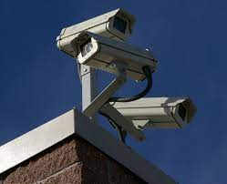

* 1. **Limitations of Existing Home Security Systems:**

There are several limitations of existing home security systems, including:

#### Limited coverage:

Traditional home security systems often rely on a limited number of sensors, which can leave blind spots that are vulnerable to break-ins.

#### False alarms:

Existing systems can be prone to false alarms, which can lead to fines and wasted resources.

#### High cost:

Some modern home security systems can be expensive to install and maintain.

#### Lack of flexibility:

Traditional home security systems are often inflexible and cannot be easily customized to meet the specific needs of a household.

#### Dependence on power and internet:

Many modern home security systems rely on power and internet connectivity, which can be disrupted during power outages or network failures.

#### Complexity:

Some modern home security systems can be complex to set up and use, which can be a barrier to adoption for some households.

**Chapter 3:**

## **System Modeling:**

The advent of smart homes and the proliferation of the Internet of Things (IoT) have revolutionized the way we live, offering unprecedented convenience and connectivity. However, as the number of connected devices in our homes increases, so does the need for robust security measures to protect our personal spaces and safeguard our loved ones. Traditional home security systems have been the go-to solution for many years, but they often fall short in terms of efficiency and adaptability in today's fast-paced world. Recognizing this gap, this thesis proposes a novel home security system that harnesses the power of artificial intelligence (AI) to enhance security measures and ensure real-time monitoring.

The objective of this project is to develop a home security system that utilizes AI-based face detection and recognition technology to bolster the existing security infrastructure. By leveraging advancements in computer vision and machine learning algorithms, this system aims to provide homeowners with an intelligent and proactive means of safeguarding their properties. The proposed system centers around a Raspberry Pi, a versatile and cost-effective control unit, along with a webcam strategically positioned at the entrance of the home.

One of the key features of this innovative system is its ability to accurately detect and recognize faces. When a person approaches the entrance, the webcam captures their image, and the system applies sophisticated AI algorithms to analyze and compare it with a database of registered family members. If the face is identified as that of a registered family member, no action is taken, ensuring a seamless and hassle-free entry. However, if the face is unrecognized, indicating the presence of an outsider, the system promptly sends a notification to the homeowner's registered email, alerting them to the potential security breach.

The inclusion of AI-based face detection and recognition technology in this home security system marks a significant departure from conventional security approaches. By leveraging the power of machine learning, the system not only provides enhanced security but also offers unparalleled convenience and remote accessibility. Homeowners can remotely monitor and control their security system using a smartphone, giving them peace of mind and the ability to respond swiftly to any emerging threats.

Furthermore, the proposed system incorporates cloud-based data storage, ensuring that critical security information is securely stored and easily accessible from anywhere, anytime. This feature enables homeowners to review historical data, track security trends, and make informed decisions regarding their home's safety.

* 1. **Improving Security With AI, IoT and Raspberry Pi:**

This security system is a great product due to the following reasons:

* + 1. Integration of Face Detection and Recognition:

The integration of face recognition and detection technology into the proposed system enhances the security of the home by ensuring that only authorized individuals are granted access. It also provides the homeowner with real-time notifications and images of who is entering and leaving the home, which can be useful in case of any security breaches.

* + 1. Comparison With Traditional Home Security Systems:

Here's a brief comparison of the proposed home automation system with security using raspberry Pi and face recognition technology with traditional home security systems:

* **Accuracy:**

The proposed system uses face recognition and detection technology to accurately identify individuals entering the home, which is more accurate than traditional home security systems that use passwords, codes, or key cards.

* **Convenience:**

The proposed system offers convenient and remote access control to the homeowner via a mobile smartphone or a web interface, which is more convenient than traditional home security systems that require physical access to the security control panel.

* **Customization:**

The proposed system is customizable and scalable, which allows homeowners to add or modify devices and sensors according to their specific needs. Traditional home security systems, on the other hand, are usually limited in terms of customization.

* **Cost-effectiveness:**

The proposed system is cost-effective because it uses inexpensive hardware such as Raspberry Pi and open-source software, which is more affordable than traditional home security systems that require expensive hardware and software.

* **Security:**

The proposed system provides a higher level of security than traditional home security systems by using face recognition and detection technology, which is difficult to hack or bypass.

Overall, the proposed home automation system with security using Raspberry Pi and face recognition technology provides better accuracy, convenience, customization, cost-effectiveness, and security compared to traditional home security systems.

* + 1. Scalability and Customization:

The system can be easily expanded by adding new devices and sensors as per the homeowner's needs. The system uses an IoT-based architecture, which allows for seamless integration of new devices and sensors.

The system also provides customization options to the homeowner. The homeowner can customize the system according to their preferences and requirements. For example, the homeowner can set up different access levels for different family members, set up custom alerts and notifications, and create custom rules and schedules for the home devices and sensors.

The system also supports third-party integrations, which allows the homeowner to integrate their favorite smart devices and services. For example, the homeowner can integrate their smart speaker with the system to control the home devices and sensors using voice commands.

* + 1. Use of Raspberry Pi and Open-Source Software:

Raspberry Pi is a low-cost, single-board computer that provides a flexible and powerful platform for building IoT-based home automation systems. It is easy to set up and configure and offers a wide range of connectivity options and software tools that can be used to build custom home automation applications. One of the main benefits of using Raspberry Pi for the proposed system is its affordability. Compared to other commercial home automation systems, Raspberry Pi is much cheaper and provides more flexibility and customization options. It also allows for easy expansion and integration of new devices and sensors, which makes it a scalable solution for home automation.

Another benefit of using Raspberry Pi is its open-source software platform. Raspberry Pi supports a wide range of open-source software tools, which allows for easy customization and integration with other software applications. This also allows for the system to be easily updated and maintained by the homeowner, without the need for specialized technical skills.

Open-source software also provides a greater level of transparency and security, as the source code is open and can be audited by the community. This reduces the risk of vulnerabilities and ensures that the system is secure and reliable.

So, using Raspberry Pi and open-source software for the proposed home automation system provides a cost-effective, flexible, and customizable solution that is easy to maintain and secure.

* 1. **Software and Hardware Used in Proposed System:**
     1. Software:

The software used in this abstract is face recognition and detection technology, which is a type of artificial intelligence (AI). This technology uses algorithms to analyze images and identify specific facial features, such as the eyes, nose, and mouth, in order to identify an individual.

In the proposed home security and automation system, a webcam is deployed at the entrance of the home, which is connected to a Raspberry Pi. The face recognition and detection technology is then used to automate access to the door, using features such as Face Detection and Face Recognition. When an authorized person approaches the door, the system identifies their face and allows them access. If an unauthorized person attempts to gain access, the system will deny them access and send an alert to the homeowner via email or other notifications.

The face recognition and detection technology used in this system is trained on a large dataset of images, allowing it to recognize a wide range of faces accurately. The technology can also be customized to meet specific needs, such as adding new faces to the system or adjusting the sensitivity of the system to different lighting conditions.

* + 1. Hardware:

Hardware used in the proposed home security and automation system:

* **Raspberry Pi:**

A small, single-board computer that serves as the control unit for the system. It runs the software and connects to other components of the system to provide remote access and control.

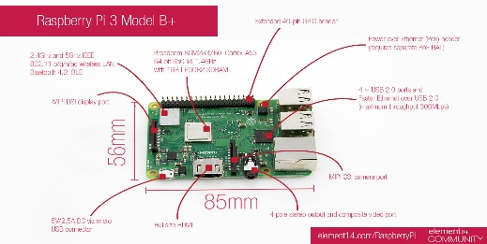

[This Photo](https://devopedia.org/raspberry-pi) by Unknown Author is licensed under [CC BY-SA](https://creativecommons.org/licenses/by-sa/3.0/)

* **PIR sensor:**

A passive infrared sensor that detects motion and changes in temperature. It is used to trigger the system when a person approaches the door, and to activate the camera and other components.

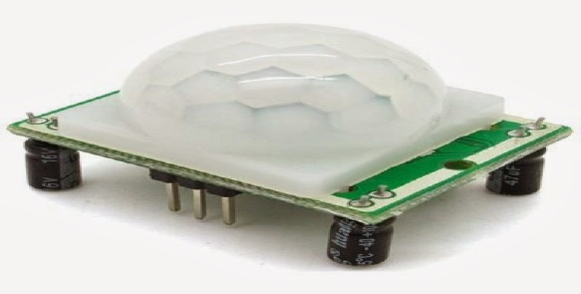

[This Photo](http://www.genotronex.com/2014/04/passive-infra-red-pir-sensor.html) by Unknown Author is licensed under [CC BY-SA-NC](https://creativecommons.org/licenses/by-nc-sa/3.0/)

* **USB Camera:**

A camera that is deployed at the entrance of the home, which is connected to the Raspberry Pi. It captures images of people who approach the door and uses face recognition and detection technology to identify them.

* 1. **Structural Model:**
     1. System Components:
* **Raspberry Pi:**

The Raspberry Pi serves as the central control unit in the proposed home security system. It is a small, single-board computer that provides the processing power and connectivity required for system operations. The Raspberry Pi enables the integration and coordination of various hardware and software components, facilitating the overall functioning of the system.

* **USB Camera:**

The USB camera is an essential hardware component in the system. It is connected to the Raspberry Pi and serves as the primary input device for capturing images or video at the entrance of the home. The camera plays a crucial role in the face detection and recognition process, allowing the system to analyze and identify individuals attempting to enter the premises.

* **PIR Sensor:**

The Passive Infrared (PIR) sensor is another key hardware component in the system. It is used to detect motion and presence in the vicinity of the entrance. The PIR sensor helps trigger the camera to start capturing images or video when movement is detected, allowing for more efficient and targeted face detection and recognition.

* **Face Detection and Recognition Software:**

The software component of the system encompasses AI-based face detection and recognition algorithms. These algorithms utilize machine learning and computer vision techniques to analyze the images or video frames captured by the USB camera. The software performs the crucial task of detecting faces, extracting facial features, and matching them against registered family members.

* **Notification System:**

The notification system is responsible for sending real-time alerts to the homeowner's registered email in case an unrecognized face is detected. It comprises software components that enable communication and integration between the system and the email service, ensuring that homeowners are promptly notified of potential security breaches.

* + 1. Relationships and Connections:
* **Raspberry Pi and USB Camera:**

The Raspberry Pi is connected to the USB camera through a USB interface. This connection allows the Raspberry Pi to receive video feed from the camera and process it for face detection and recognition.

* **Raspberry Pi and PIR Sensor:**

The Raspberry Pi is connected to the PIR sensor, typically through GPIO (General Purpose Input/Output) pins. This connection enables the Raspberry Pi to receive signals from the PIR sensor and detect motion or presence near the entrance.

* **USB Camera and Face Detection/Recognition Software:**

The USB camera serves as the input device for the face detection and recognition software. The camera captures images or video frames, which are then processed by software to detect faces, extract facial features, and perform recognition algorithms.

* **Notification System and Email Service:**

The notification system is connected to an email service through appropriate protocols and APIs. When an unrecognized face is detected, the notification system triggers the email service to send an alert notification to the homeowner's registered email address.

* + 1. Class Diagram & Details:

The table below shows the details of AI Based Residential Security System **Class Diagram** and has a complete description of the project’s information.

|  |  |
| --- | --- |
| Name | AI Based Residential Security System ER Diagram |
| Abstract | AI Based Residential Security System Class Diagram depicts the relationship between various classes. |
| Diagram | Class Diagram. |
| Tools Used | Diagramming Tools from MS Visio. |
| Users | Homeowners, Managers etc. |
| Designer | Project Developers. |

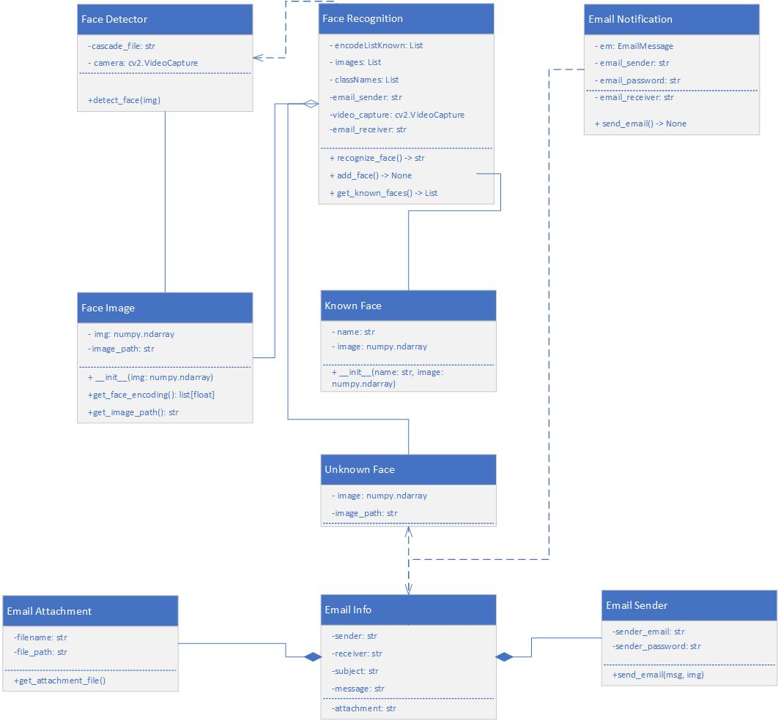

* 1. **Behavioral Model:**
     1. System Operation:

When a person approaches the entrance of the home, the motion sensor detects their movement and triggers the system. The USB camera is activated, capturing live video footage of the individual. Using AI-based face detection algorithms, the system analyzes the video stream to locate and identify any faces present. The detected faces are then compared against registered family members using face recognition technology. If a recognized face is detected, no further action is taken. However, if an unrecognized face is detected, the system generates a notification and sends it to the homeowner's registered email address in real-time, alerting them about the presence of an unknown person.

* + 1. Face Verification Process:

The face verification process involves several steps to determine if a detected face belongs to a registered family member. First, the system detects and extracts facial features from the detected face. Then, it compares these features with the stored facial features of registered family members. By applying matching algorithms and setting a threshold, the system determines if the detected face is a match or not. If it is a match, no further action is taken. However, if the face is not recognized, the system generates a notification to alert the homeowner via email about the presence of an outsider. This process ensures accurate verification and prompt notifications for potential security breaches.

* + 1. Continuous Monitoring:

The system remains in a state of continuous monitoring, repeating the face detection and recognition process if motion is detected at the entrance. This ensures ongoing surveillance and real-time notification in case of any unrecognized faces.

* + 1. Sequence Diagram & Details

The table below shows the details of AI Based Residential Security System **Sequence Diagram** and has a complete description of the project’s information.

|  |  |
| --- | --- |
| Name | AI Based Residential Security System Sequence Diagram |
| Abstract | AI Based Residential Security System Sequence Diagram depicts the relationship between various entities. It can be thought of as a blueprint for our system (project) structure. |
| Diagram | Sequence Diagram. |
| Tools Used | Diagramming Tools from MS Visio |
| Users | Homeowners, Managers etc. |
| Designer | Project Developers. |

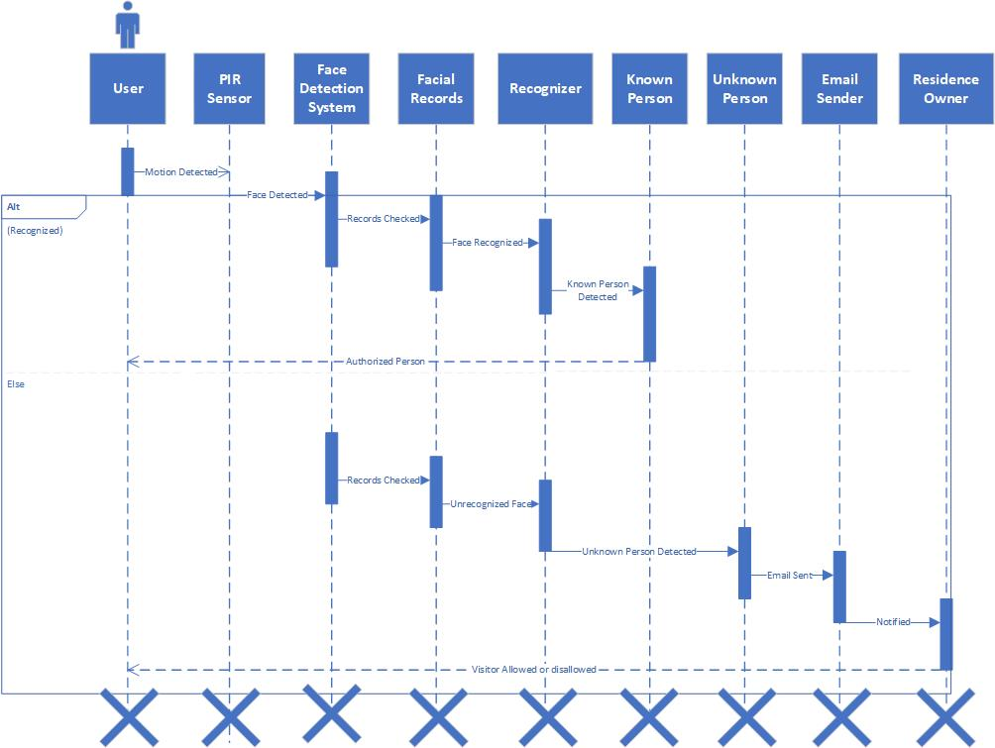

* + 1. Flowchart Diagram & Details:

The table below shows the details of AI Based Residential Security System **Flowchart Diagram** and has a complete description of the project’s information.

|  |  |
| --- | --- |
| Name | AI Based Residential Security System Flowchart Diagram |
| Abstract | AI Based Residential Security System Flowchart Diagram depicts the relationship between various objects. |
| Diagram | Flowchart Diagram. |
| Tools Used | Diagramming Tools from MS Visio |
| Users | Homeowners, Managers etc. |
| Designer | Project Developers. |

* 1. **Data Model:**

The following diagram explain the data model for my system.

* + 1. Entity Relationship Diagram:

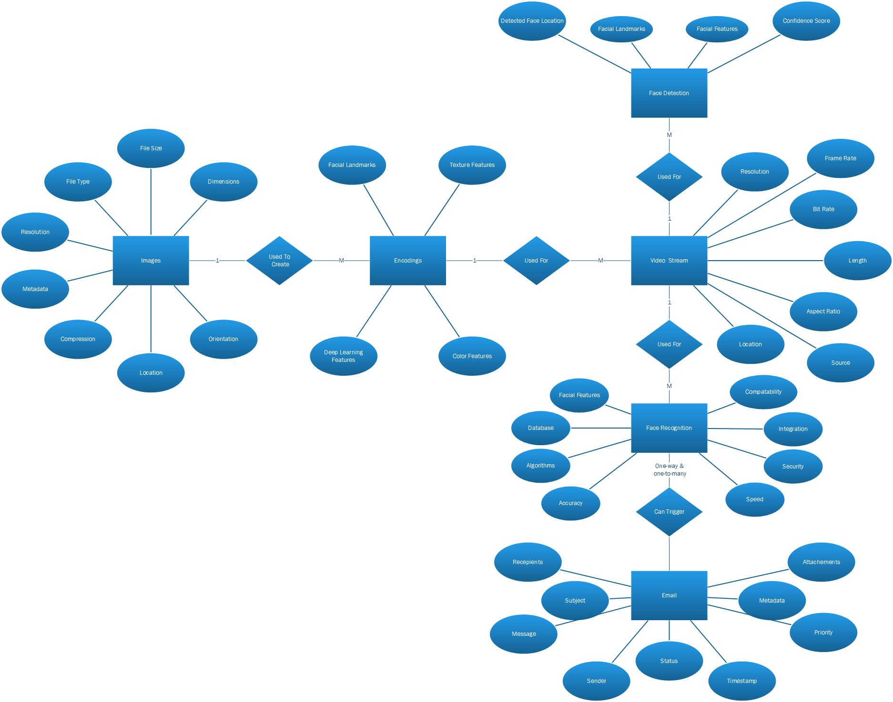

* 1. **System Development Environment & Tools:**
     1. Development Environment:
* **Artificial intelligence (AI)**

is used in the system to enable facial recognition and detection features, which are important for identifying individuals and ensuring secure access to the home. Machine learning algorithms, which are a subset of AI, are also likely to have been used to improve the accuracy and efficiency of the facial recognition and detection system.

* **Python**

is a high-level programming language that is popular for its readability, ease of use, and wide range of libraries and frameworks. It is likely that Python was used to write the code for the system, given its popularity in the development of IoT and machine learning applications.

* **Computer vision**

is an interdisciplinary field that deals with how computers can be made to interpret and understand visual data from the world around them. In the proposed system, computer vision is used to analyze visual data from the web camera, enabling the facial recognition and detection features of the system.

* **Raspberry Pi**

is a small, single-board computer that is commonly used in IoT applications. In the proposed system, the Raspberry Pi serves as the control unit for the home automation and security system. It is connected to various hardware components, such as the PIR sensor, GSM module, relay, and web camera, and runs the software necessary to control and monitor these components.

* + 1. Development Tools:
* **PyCharm**
* **Raspberry Pi**
* **Geany**
  + 1. Project Documentation:
* **MS Office**
* **MS Word**
* **MS Power Point**
  + 1. Project Diagrams
* **MS Visio**